CGIAR-CSI Global Aridity Index (Global-Aridity) and Global Potential Evapo-Transpiration (Global-PET) Climate Database:
Document Updated: Oct. 2009
These datasets have been downloaded and are available from the CGIAR-CSI GeoPortal (http://www.csi.cgiar.org). The Consortium for Spatial Information (CGIAR-CSI) is an initiative of the Consultative Group for International Agriculture Research (CGIAR), linking the international science, research and development communities, with CGIAR scientists, national and international partners, and others working to apply and advance geospatial science for sustainable development, conservation, and poverty alleviation in developing countries.
The CGIAR-CSI Global Aridity Index (Global-Aridity) and Global Potential Evapo-Transpiration (Global-PET) geo-spatial datasets have been produced by Antonio Trabucco, currently at the Forest Ecology and Management Research Group , K.U. Leuven, with the support of the International Water Management Institute (IWMI), and the International Centre for Integrated Mountain Development (ICIMOD), and are provided online by the CGIAR-CSI and the International Center for Tropical Agriculture (CIAT). The Global-Aridity and Global-PET datasets are provided for non-commercial use in standard ESRI grid geospatial format, at 30 arc seconds or ~ 1km at the equator, to support studies contributing to sustainable development, biodiversity and environmental conservation, poverty alleviation, and adaption to climate change globally, and in particular in developing countries. The methods used to derive these datasets, and the data dictionary are described briefly below, and discussed further in Trabucco et al. (2008), Zomer et al. (2008) and Zomer et al. (2007).
The proper citation for this dataset is:
Trabucco, A., and Zomer, R.J. 2009. Global Aridity Index (Global-Aridity) and Global Potential Evapo-Transpiration (Global-PET) Geospatial Database. CGIAR Consortium for Spatial Information. Published online, available from the CGIAR-CSI GeoPortal at: http://www.csi.cgiar.org.
Comments, feedback, suggestions or bug reports regarding downloading of the Global-PET and Global-Aridity datasets should be sent to: csi@cgiar.org. Technical questions regarding the Global-PET and Global-Aridity datasets can be directed to Antonio Trabucco: Antonio.Trabucco@ees.kuleuven.be
Methods and Dataset Description:
Global Aridity Index (Global-Aridity) and Potential Evapo-Transpiration (Global-PET)
Potential Evapo-Transpiration (PET) is a measure of the ability of the atmosphere to remove water through Evapo-Transpiration (ET) processes. The FAO introduced the definition of PET as the ET of a reference crop under optimal conditions, having the characteristics of well watered grass with an assumed height of 12 centimeters, a fixed surface resistance of 70 seconds per meter and an albedo of 0.23 (Allen et al. 1998). Among several equations to estimate PET, a FAO application of the Penman-Monteith equation (Allen et al. 1998), here referred as FAO-PM, is currently widely considered as a standard method (Walter et al. 2000). The FAO-PM is a predominately physically based approach, which can be used globally because it does not require estimations of additional site-specific parameters. However, a major drawback of the FAO-PM method is its relatively high need for specific data for a variety of parameters (i.e. windspeed, relative humidity, solar radiation, etc.) These parameters are reliably observed by a limited number of meteorological stations around the globe, and are especially lacking in developing countries (Droogers & Allen, 2002).
The Global-Aridity and Global-PET are both modeled using the data available from the WorldClim Global Climate Data (Hijmans et al. 2005) as input parameters. The WorldClim, based on a high number of climate observations and SRTM topographical data, is a high-resolution global geo-database (30 arc seconds or ~ 1km at equator) of monthly average data (1950-2000) for the following climatic parameters: precipitation, mean, minimum and maximum temperature. This set of parameters is insufficient to fully parameterize physical radiation-based PET equations (i.e. the FAO-PM), though can parameterize simpler temperature-based PET equations.
Monthly average PET was spatially characterized and then tested using 4 different temperature-based methods applied to the WorldClim Global Climate Data to determine their prediction accuracy. The modes that were used and tested are Thornthwaite (1948), Thornthwaite modified by Holland (1978), Hargreaves et al. (1985), Hargreaves modified by Droogers and Allen (2002). The monthly average values using these high resolution temperature PET layers, together with existing medium resolution (10’) FAO-PM monthly average (1950-2000) PET layers (FAO 2004), were compared to Penman-Monteith PET values estimated at climate stations in South America and Africa (n = 2288). The PET station estimates used in the validation are calculated using the more complex Penman–Monteith model applied on direct observations of the various climatic parameters, and were obtained from the FAOCLIM 2 climate station dataset (Allen et al., 1998), available online from FAO. Based on the results of the comparative validation (Table 1) for South America and Africa (Figure 1), the Hargreaves model was chosen as the most suitable to model PET globally. This method performed almost as well as the FAO-PM, but required less parameterization, with significantly reduced sensitivity to error in climatic inputs (Hargreaves and Allen 2003).
Hargreaves (1985) uses mean monthly temperature (Tmean), mean monthly temperature range (TD) and mean monthly extra-terrestrial radiation (RA, radiation on top of atmosphere) to calculate mean PET, as shown below:
PET = 0.0023 · RA · (Tmean + 17.8) · TD0.5 (mm / day)
Average monthly and annual PET (mm) layers at spatial resolution of 30 arc-seconds (~ 1km at tropics) for the 1950-2000 period are calculated using the Hargreaves method with available layers of monthly average temperature parameters, available from WorldClim database, and monthly extra-terrestrial radiation, calculated using a methodology presented by Allen et al. (1998). Temperature range (TD) is an effective proxy to describe the effect of cloud cover on the quantity of extra-terrestrial radiation reaching the land surface and, as such, it describes more complex physical processes with easily available climate data at high resolution.

Table 1. Five different methods of calculating PET were tested to verify which performed the best for the objectives of this analysis: Thornthwaite (Thornthwaite 1948), Thornthwaite modified by Holland (Holland 1978), Hargreaves (Hargreaves et al. 1985), Hargreaves modified by Droogers (Droogers and Allen 2002), and the FAO Global Penman-Monteith Dataset (Allen et al. 1998). Results are given as the mean difference (Diff) between observed and predicted estimates, and their standard deviations (SD).
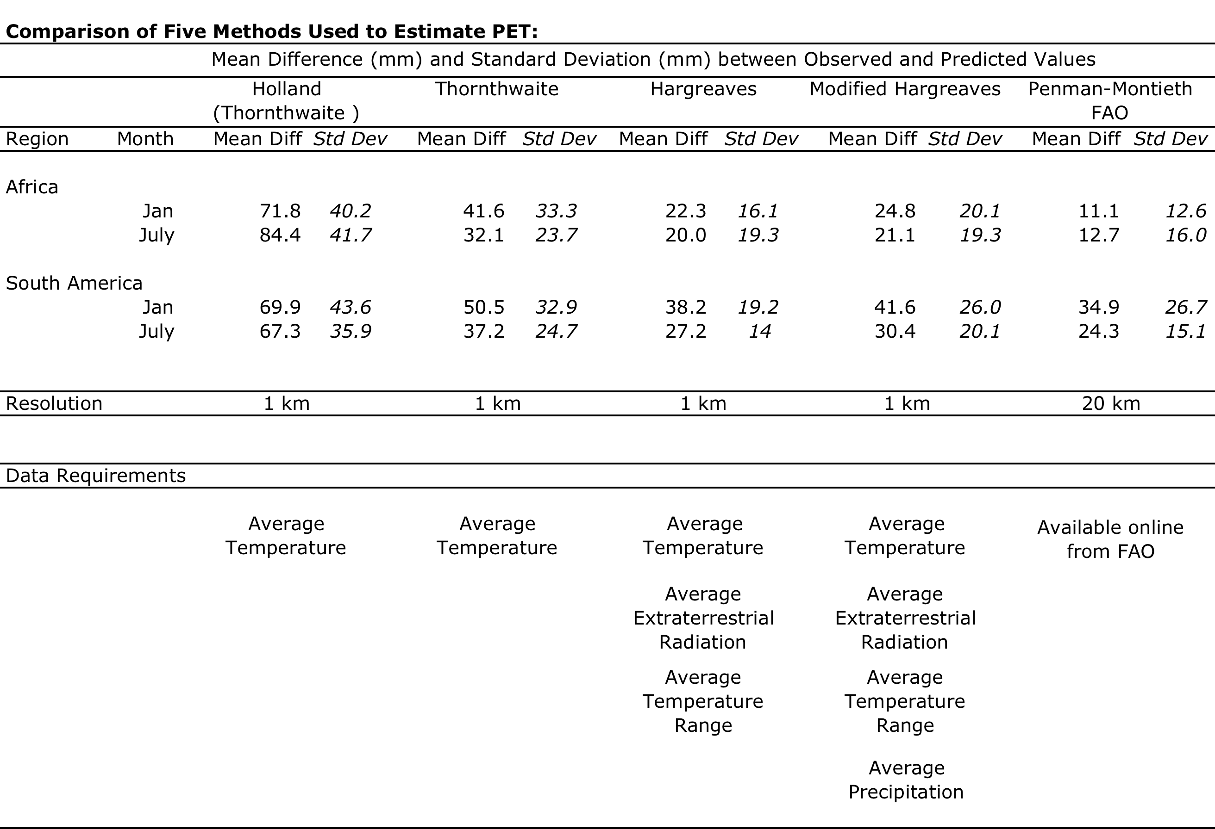
Figure 1. Five methods used to calculate PET for South America and Africa during two seasons.
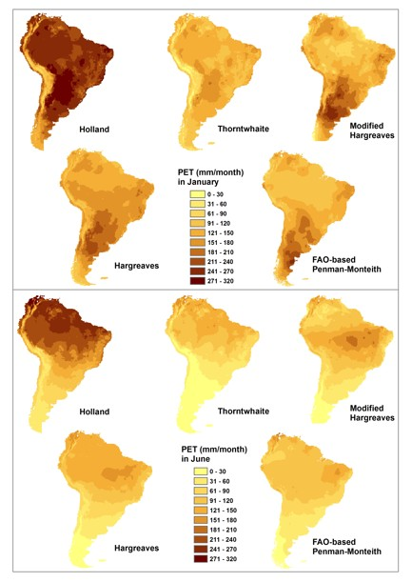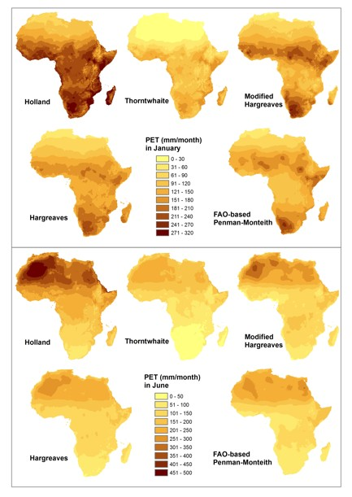

Global Aridity Index (Global-Aridity)
Aridity is usually expressed as a generalized function of precipitation, temperature and potential evapo-transpiration (PET). An Aridity Index (UNEP, 1997) can be used to quantify precipitation availability over atmospheric water demand.
Global mapping of mean Aridity Index from the 1950-2000 period at 30’ spatial resolution is calculated as:
Aridity Index (AI) = MAP / MAE [2]
where:
MAP = Mean Annual Precipitation
MAE = Mean Annual Potential Evapo-Transpiration
Note: In the Global-Aridity dataset, which uses this formulation, Aridity Index values increase for more humid conditions, and decrease with more arid conditions.

Mean annual precipitation (MAP) values were obtained from the WorldClim Global Climate Data (Hijmans et al. 2005), for years 1950-2000, while PET layers estimated on a monthly average basis by the Global-PET (i.e. modeled using the Hargreaves method, as described above) were aggregated to mean annual values (MAE).
The Global-Aridity surface (Figure 2) shows moisture availability for potential growth of reference vegetation excluding the impact of soil mediating water runoff events. UNEP (UNEP 1997) breaks up Aridity Index, in the traditional classification scheme presented in Table 2.

Figure 2. Global Aridity Index (Global -Aridity) was calculated for the entire globe. Aridity maps for South America and Africa are shown below. Note that higher AI and darker color represents more humid conditions, with low AI and lighter colors representing higher aridity.
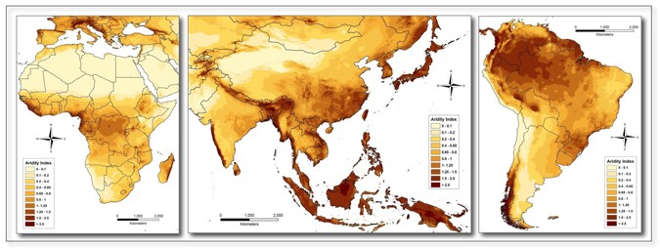

Table 2. Generalized climate classification scheme for Global-Aridity values (UNEP 1997).
Aridity Index Value Climate Class
< 0.03 Hyper Arid
0.03 – 0.2 Arid
0.2 – 0.5 Semi-Arid
0.5 – 0.65 Dry sub-humid
> 0.65 Humid

DATA FORMAT
Global-PET grid layers are available as monthly averages (12 data layers, i.e. one layer for each month, averaged over the 1950-2000 period) or as an annual average (1 data layer) for the 1950-2000 period.
Global-Aridity is available as one grid layer representing the annual average over the 1950-2000 period.
The following nomenclature is used to describe the dataset:
Prefix is either:
PET_HE_ for PET layers calculated based on Hargreaves Method
AI for Aridity Index
Suffix is either:
1, 2, ... 12 Month of the year
YR Yearly average
Examples:
PET_HE_2 is the PET average for the month of February
PET_HE_YR is the PET annual average
AI_YR is the AI annual average

The Global-PET geodataset values are defined as total mm of PET per month or per year.
The Aridity Index values reported within the Global-Aridity geodataset have been multiplied by a factor of 10,000 to derive and distribute the data as integers (with 4 decimal accuracy). This multiplier has been used to increase the precision of the variable values without using decimals (real or floating values are less efficient in terms of computing time and space compared to integer values). Global-Aridity values need to be multiplied for 0.0001 to retrieve the values in the correct units.
The geospatial dataset is in geographic coordinates; datum and spheroid are WGS84; spatial units are decimal degrees. The spatial resolution is 30 arc-seconds or 0.008333 degrees. Arc degrees and seconds are angular distances, and conversion to linear units (like km) varies with latitude, as below:
Latitude Linear distance equivalent to 30 arc sec
0 0.9266 km
20 0.8707 km
40 0.7098 km
60 0.4633 km

The Global-PET and Global-Aridity data layers are processed and finalized in ARC/INFO grid data format. These layers have been zipped (.zip) into monthly series or individual annual layers available for online access.

Data Use and Distribution
This data has been generated by not-for-profit institutions with the objective of supplying accessible and useful information to developing country organizations. We actively encourage use of these products for scientific purposes. This is not however the case for commercial purposes. The entire dataset is available for commercial use at a modest cost, but permission must be sought. Commercial sectors interested in using this data should contact Antonio Trabucco at: Antonio.Trabucco@ees.kuleuven.be
This dataset should be cited as follows:
Trabucco, A., and Zomer, R.J. 2009. Global Potential Evapo-Transpiration (Global-PET) and Global Aridity Index (Global-Aridity) Geo-Database. CGIAR Consortium for Spatial Information. Available online from the CGIAR-CSI GeoPortal at: http://www.csi.cgiar.org

References:

Allen R.G., Pereira L.S., Raes D. & Smith M. 1998. Crop evapotranspiration: Guidelines for computing crop requirements. Irrigation and Drainage Paper No. 56, FAO, Rome, Italy.
Droogers P. and R.G. Allen. 2002. Estimating reference evapotranspiration under inaccurate data conditions. Irrigation and Drainage Systems, Volume 16, Issue 1, February 2002, Pages 33 - 45
Fao, 2004. Global map of monthly reference evapotranspiration - 10 arc minutes. Available at: http://www.fao.org/geonetwork/srv/en/main.home.
FAO. 2001. FAOCLIM - world-wide agroclimatic data. Version 2. FAO – SDRN (Environment and Natural Resources Service). Rome.
Hargreaves, G.H., Allen, R.G., 2003. History and evaluation of Hargreaves evapotranspiration equation. J. Irrig. Drain. Eng. ASCE 129 (1), 53–63.
Hargreaves, G.L., Hargreaves, G.H., Riley, J.P., 1985. Irrigation water requirements for Senegal River Basin. J. Irrig. Drain. Eng. ASCE 111 (3), 265–275.
Hijmans, R.J., Cameron, S.E., Parra, J.L., Jones, P.G. & Jarvis, A. (2004) The WorldClim interpolated global terrestrial climate surfaces, version 1.3 . Available at http://biogeo.berkeley.edu/.
Holland, H.D., 1978. The Chemistry of the Atmosphere and Oceans.Wiley, New York.
Thornthwaite, C., 1948. An approach toward a rational classification of climate. Geogr. Rev. 38 (1), 55–94.
Trabucco, A., Zomer, R.J., Bossio, D.A., van Straaten, O., Verchot, L.V. 2008. Climate Change Mitigation through Afforestation / Reforestation: A global analysis of hydrologic impacts with four case studies. Agric. Ecosystems and Environment. 126: 81-97.
UNEP (United Nations Environment Programme), 1997. World atlas of desertification 2ED. UNEP, London.
Walter I.A., Allen R.G., Elliott R.,Mecham B., JensenM.E., Itenfisu D., Howell T.A., Snyder R., Brown P., Echings S., Spofford T., HattendorfM., Cuenca R.H.,Wright J.L.&Martin D. 2000. ASCE Standardized Reference Evapotranspiration Equation, p. 209–215. In: Evans RG, Benham BL, Trooien TP (eds.) Proc. National Irrigation Symposium, ASAE, Nov. 14–16, 2000, Phoenix, AZ.
Zomer, R.J., Trabucco, A., Bossio, D.A, van Straaten, O., Verchot, L.V. 2008. Climate Change Mitigation: A Spatial Analysis of Global Land Suitability for Clean Development Mechanism Afforestation and Reforestation. Agric. Ecosystems and Envir. 126: 67-80.

Zomer, R.J., Bossio, D.A., Trabucco, A., Yuanjie, L., Gupta, D.C., Singh, V.P. 2007. Trees and Water: Smallholder Agroforestry on Irrigated Lands in Northern India. Colombo, Sri Lanka: International Water Management Institute. pp 45. (IWMI Research Report 122).

